**Progess Update**

**Date: 2020-12-23**

1. Added a *render()* in *objectBaseType.ts,* which returns a Promise to *doAction()* and then update the data.
2. Added *rootType.ts* and *demographicType.ts* with corresponding render function.
3. Added a subtype parsing function in r*eferenceObjectBaseType* class which returns the subtype default value.
4. Added the render function for *object* type.
5. Added a switch statement for checking subtype and creating appropriate object in *listType.ts*,.
6. Fixed the issue that removing button didn’t work.

**Remaining Tasks and Issues for Code Refactoring**

1. Need to complete the code refactoring for List, Dictionary/LocalizedDictionary, and typeless types.
2. When all sub-items under a node are removed, any action including expanding that node will trigger the error:

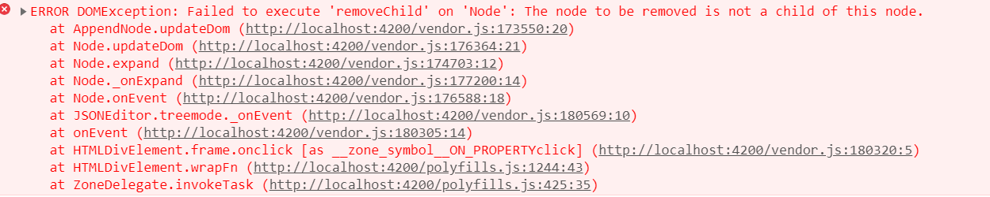

1. If creating a new demographic node, then adding any new items under that node won’t work properly:

